ResourceHive

Software Architecture Document

Version <1.0>

Revision History
Date | Version | Description | Author
<dd/mmm/yy> | <x.x> | <details> | <name>

Note: When you include figures
- Use figure numbers and figure captions.
- Use diagrams/ images/ screen shots with high resolution to get a clear figure
- Use the figure captions in the form of Figure 1. <<caption>> and when explain it in the text, use the abbreviation “Figure 1,” even at the beginning of a sentence.
- When you use a tool to draw diagrams, change the font settings of the diagram; It is better to have font in black colour/ large in size (12pt) and if possible do not fill the objects/ elements in the diagram with a colour (keep the background colour white, for clear visibility)
- Also, try to re-locate the objects closely in a way that take less space (you may drag elements/objects close to each other).
- This will be useful to get a clear image; in order to make the diagram small in size without reducing the resolution quality.
- When you include images in your reports, make them “in line with text” ( picture tool bar 🡪 wrap text 🡪 in line with text) and include the caption accordingly. If you include two or more images together ( in a row), group them.
- Describe each diagram with few sentences.

When you draw diagrams (eg. Sequence diagram) do not include only two object called “user” and “system”. Include all the internal objects within the system, without considering the system as a black box. For example: for a mobile application the main system may consists of sub objects such as , <<UI>>:main_Interface, :controller, <<UI>>:analysis_Interface, :local_DB, etc. (this is only an example; use your own terms).

References:
- Indicate the tools you have used to draw the diagrams
Useful theory for design diagrams : (relationships in Class diagram)
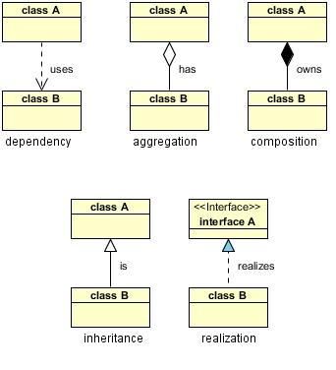

Table of Contents
1. Introduction 2
1.1 Purpose 2
1.2 Scope 2
1.3 Definitions, Acronyms, and Abbreviations 2
1.4 References 2
1.5 Overview 2
2. Architectural Representation 2
3. Architectural Goals and Constraints 2
4. Use-Case View 2
4.1 Use-Case Realizations 2
5. Logical View 2
5.1 Overview 2
5.2 Architecturally Significant Design Packages 2
6. Process View 2
7. Deployment View 2
8. Implementation View 2
8.1 Overview 2
8.2 Layers 2
9. Data View (optional) 2
10. Size and Performance 2
11. Quality 2

Software Architecture Document

Introduction
ResourceHive is a multi-tenant software platform intended to replace fragmented resource-management processes such as spreadsheets, noticeboards, email conversations, and informal messaging. It provides one verified and auditable workflow through which institutional users can discover, reserve, use, return, and review shared resources. The platform organizes customers as root organizations, each representing an independent tenant. Faculties, departments, clubs, laboratories, and other internal groups are represented as child organizations inside that tenant. Users may belong to more than one organization, but all access to tenant-owned information must be evaluated against the appropriate root organization, approved memberships, resource permissions, and administrative authority.

Purpose

The purpose of this document is to describe the significant architectural decisions that shape ResourceHive and explain how the system satisfies its functional and non-functional requirements.
The document is intended for:
- Project developers, who must understand service boundaries and dependency rules.
- Testers, who must identify required functional, authorization, database, and concurrency tests.
- Lecturers and reviewers, who must evaluate the consistency of the proposed design.
- Deployment operators, who must understand containers, gateway routing, configuration, migrations, health checks, and recovery.
- Future maintainers, who must understand why particular technical and database decisions were made.
The document connects user requirements to software services, domain classes, runtime interactions, persistent entities, deployment nodes, security boundaries, and quality controls. Particular attention is given to multi-tenancy, inherited organization administration, atomic booking and point deduction, database concurrency, append-only audit records, notification reliability, and provider-independent deployment.

Scope

The ResourceHive target architecture includes:
- A public marketing website.
- An authenticated web application.
- Institutional registration and email verification.
- Password login, account recovery, OAuth linking, access tokens, and refresh tokens.
- Root-tenant onboarding.
- Parent and child organization management.
- Organization email-domain and allowlist management.
- Membership requests, approvals, rejection, and suspension.
- Organization-administrator authorization.
- Resource creation, modification, activation, and access configuration.
- Resource availability-slot management.
- Resource discovery based on approved memberships and allowed organizations.
- Atomic booking creation and point deduction.
- Booking cancellation and policy-based refund.
- Booking completion and resource return.
- Joining bonuses and semester-based point allocations.
- Append-only point-history and balance calculation.
- Persistent recipient-scoped notifications.
- Real-time notification delivery.
- Resource ratings after completed bookings.
- Booking disputes and append-only dispute histories.
- Tenant-scoped administrative analytics.
- API gateway routing, health endpoints, and OpenAPI documentation.
- Containerized backend deployment and frontend hosting.
- Shared PostgreSQL persistence managed through committed migrations.
The architecture uses one shared PostgreSQL database. It does not use one database per tenant and does not require PostgreSQL Row-Level Security for the initial architecture. Tenant isolation is instead achieved through application authorization, tenant-scoped Prisma queries, composite database relationships, constraints, and integrity tests.

Definitions, Acronyms, and Abbreviations
Term | Definition
API | Application Programming Interface.
API gateway | The public Nginx entry point that routes requests to internal backend services.
Approved membership | An organization membership whose status is APPROVED. Only approved memberships grant normal organization access.
Booking | A reservation connecting one user to one resource-availability slot.
Child organization | An organization whose parent_id refers to another organization in the same tenant.
CI | Continuous Integration - Automated installation, validation, build, and testing performed by GitHub Actions.
CORS | Cross-Origin Resource Sharing - The browser-origin policy used between the web application and API.
DTO | Data Transfer Object used to validate and describe request data.
Identity Service | The backend service that owns signup, verification, login, password hashing, JWT creation, and user identity.
JWT | JSON Web Token used to carry signed authentication claims.
Membership role | An organization-level role: ADMIN or MEMBER.
Membership status | PENDING, APPROVED, REJECTED, or SUSPENDED.
Organization | A root tenant or an internal unit such as a faculty, department, club, office, or team.
Organization admin | A user with an approved ADMIN membership in an organization.
Platform admin | A ResourceHive operator whose platform role is PLATFORM_ADMIN.
Points ledger | The append-only history of joining bonuses, booking deductions, and booking refunds.
Prisma | The ORM and migration tool used to access and manage PostgreSQL.
Resource | A shareable facility or item owned by an organization.
Resource owner organization | The organization responsible for a resource.
RLS | PostgreSQL Row-Level Security. It is not part of the initial ResourceHive authorization design.
Root organization | The top-level organization represents one tenant. Its root_organization_id refers to its own ID.
SaaS | Software as a Service.
Service-local authentication | JWT verification performed inside the Resource, Booking, or Notification Service without contacting Identity Service on every request.
SMTP | Simple Mail Transfer Protocol used by the production email transport.
Tenant | One top-level customer using the shared ResourceHive installation. The tenant boundary is represented by root_organization_id.
Tenant isolation | Prevention of access between different root organizations.
UUID | Universally Unique Identifier used for database record identifiers.
Verification token | A single-use, time-limited token used to prove control of a signup email address.
Booking Service | The backend service that owns resource slots, booking creation, cancellation, completion, point deductions, refunds, semester allocations, and booking disputes.
ERD | Diagram showing database entities and relationships.
Notification Service | The backend service that owns persistent recipient scoped notifications and approved notification delivery mechanisms.
OAuth 2.0 / OIDC | Standard protocols used for approved external account linking or authentication-provider integration.
ORM | Object-Relational Mapping, a technique used to access relational data through application-level models. ResourceHive uses Prisma as its ORM.
PostgreSQL | The shared relational database used as the authoritative persistent data store for ResourceHive.
Redis | An optional in-memory data store that may support caching, rate limiting, notification pub/sub, or WebSocket coordination.
Resource Service | The backend service that owns organizations, memberships, organization hierarchy, resources, and resource-access rules.

References

[1] ISO/IEC/IEEE, “Software, systems and enterprise-Architecture description,” ISO/IEC/IEEE 42010:2022, 2022. [Online]. Available: https://www.iso.org/standard/74393.html. [Accessed: 08-Aug-2026].
[2] Object Management Group, “Unified Modeling Language Specification, Version 2.5.1.” [Online]. Available: https://www.omg.org/spec/UML/. [Accessed: 08-Aug-2026].
[3] draw.io, “draw.io Diagramming Tool.” [Online]. Available: https://www.drawio.com/. [Accessed: 08-Aug-2026].
[4] PlantUML, “PlantUML Documentation.” [Online]. Available: https://plantuml.com/. [Accessed: 08-Aug-2026].
[5] Vercel, “Next.js Documentation.” [Online]. Available: https://nextjs.org/docs. [Accessed: 29-Jul-2026].
[6] NestJS, “NestJS Documentation.” [Online]. Available: https://docs.nestjs.com/. [Accessed: 29-Jul-2026].
[7] PostgreSQL Global Development Group, “PostgreSQL 15 Documentation.” [Online]. Available: https://www.postgresql.org/docs/15/. [Accessed: 29-Jul-2026].
[8] Prisma, “Prisma ORM Documentation.” [Online]. Available: https://www.prisma.io/docs/orm. [Accessed: 29-Jul-2026].
[9] Docker, “Docker Compose Documentation.” [Online]. Available: https://docs.docker.com/compose/. [Accessed: 29-Jul-2026].
[10] Nginx, “Nginx Documentation.” [Online]. Available: https://nginx.org/en/docs/. [Accessed: 29-Jul-2026].
[11] OpenAPI Initiative, “OpenAPI Specification.” [Online]. Available: https://spec.openapis.org/oas/latest.html. [Accessed: 29-Jul-2026].
[12] GitHub, “GitHub Actions Documentation.” [Online]. Available: https://docs.github.com/en/actions. [Accessed: 29-Jul-2026].
[13] M. Jones, J. Bradley, and N. Sakimura, “JSON Web Token (JWT),” RFC 7519, Internet Engineering Task Force, May 2015. [Online]. Available: https://www.rfc-editor.org/info/rfc7519/. [Accessed: 29-Jul-2026].
[14] World Wide Web Consortium, “Web Content Accessibility Guidelines (WCAG) 2.2.” [Online]. Available: https://www.w3.org/TR/WCAG22/. [Accessed: 29-Jul-2026].

Overview
Section 2 explains the architectural views used to describe ResourceHive. Section 3 presents the goals, constraints, and significant architectural decisions. Section 4 describes architecturally important use cases. Section 5 presents the logical organization of the domain. Section 6 explains runtime processes, transactions, and failure handling. Section 7 maps the applications and services to their deployment environment. Section 8 describes the implementation structure and dependency rules. Section 9 describes persistent entities and database integrity. Sections 10 and 11 explain performance and quality characteristics. Section 12 lists the referenced project and external sources.

Architectural Representation

ResourceHive is described through several complementary views because no single diagram can communicate every relevant aspect of the system. The use-case view describes the goals of visitors, approved members, organization administrators, and platform administrators. The logical view describes the domain entities and relationships. The process view describes how software components collaborate at runtime. The deployment view maps executables to infrastructure. The implementation view describes code organization and dependencies. The data view describes persistent entities and database integrity controls.

View | Purpose | Principle elements
Use-case view | Describes architecturally significant user goals | Actors, use cases, preconditions, flows and outcomes
Logical view | Describes the static domain structure | Users, organizations, memberships, resources, bookings, points, ratings and disputes
Process view | Describes runtime behaviour | Gateway routing, JWT validation, authorization, transactions and notifications
Deployment view | Describes physical execution | Browser, Vercel, Nginx, Docker containers, PostgreSQL and SMTP
Implementation view | Describes source-code organization | Applications, services, shared packages and layers
Data view | Describes persistent integrity | Tables, keys, indexes, constraints, triggers and transactions

Architectural Goals and Constraints

Architectural Goals

Tenant isolation
All tenant-owned data must remain inside the correct root_organization_id boundary. Knowing another tenant’s object identifier must not allow a user to access that object. Authorization must therefore apply to direct object requests as well as data displayed through the frontend.

Correct concurrent booking
Concurrent attempts to book the same slot must produce no more than one active booking. Application checks alone are insufficient because two requests may observe the same slot as available. ResourceHive therefore combines application validation, database transactions, locking, and database uniqueness.

Atomic booking and points processing
A confirmed booking and its negative BOOKING point transaction must either both commit or both roll back. The system must never create a booking without its deduction or deduct points without creating the corresponding booking.

Auditable point history
ResourceHive maintains point balances through an append-only ledger rather than a mutable balance field. Joining bonuses, semester allocations, booking deductions, and refunds are separate immutable events. The current balance is calculated from the sum of these transactions.

Understandable service ownership
Identity, organization/resource, booking/points, and notification responsibilities are placed in separate services. The shared database does not permit one service to take over another service’s business logic.

Provider independence
Database, frontend-hosting, backend-hosting, SMTP, OAuth, and DNS providers are selected through configuration. Vendor-specific APIs must not appear inside core domain rules unless an approved adapter isolates them.

Maintainability and verification
Every feature must include validation, authorization, tests, API documentation, container readiness, configuration documentation, and health checks where applicable. A feature is not considered complete merely because a page or endpoint exists.

Architectural Constraints

The approved architecture contains:
- Two Next.js frontend applications: the marketing website and main authenticated application.
- Four independent NestJS services: Identity, Resource, Booking, and Notification.
- One Nginx API Gateway.
- One shared PostgreSQL database.
- Prisma and committed versioned migrations.
- Docker Compose for backend orchestration.
- GitHub Actions for continuous integration.
- Vercel for hosting the frontend applications.
- One Docker-capable backend host for the initial deployment.
The tenant boundary is root_organization_id. Child organizations use parent_id. Users are global and are connected to organizations through memberships.
No service may trust a tenant identifier, organization identifier, user identifier, or role supplied by the frontend without checking authoritative data. Nginx must not contain organization-authorization rules.
Protected services validate access-token signatures and expiry locally through the approved shared authentication package. They must not call the Identity Service for every protected request.
Redis must not replace PostgreSQL transactions, constraints, or authoritative records. It may only support justified functions such as caching, rate limiting, pub/sub, or WebSocket coordination.

Significant Architectural Decisions
Decision | Rationale | Consequence
One shared PostgreSQL database | Supports atomic booking and point changes and central tenant integrity | Services require strict logical ownership despite physical sharing
Local JWT validation | Removes a network call to Identity Service from each request | Signing configuration and claim interpretation must remain consistent
Application-level tenant authorization | Tenant permission depends on memberships and organization ancestry | Every tenant-owned query must include validated tenant context
Append-only point ledger | Preserves history and supports reconciliation | Point balances require aggregation and appropriate indexes
PostgreSQL booking constraints | Application checks cannot prevent every concurrency race | Migrations contain exclusion and partial-unique indexes
Independently runnable services | Maintains clear technical ownership and deployability | Each service needs its own Dockerfile, health endpoint and configuration
Provider-neutral integrations | Reduces dependency on a particular hosting vendor | Provider details belong in configuration and adapters
Persistent notification record | Users must retain notification history during delivery failures | WebSocket or Redis failure cannot remove or roll back the notification

Use-Case View

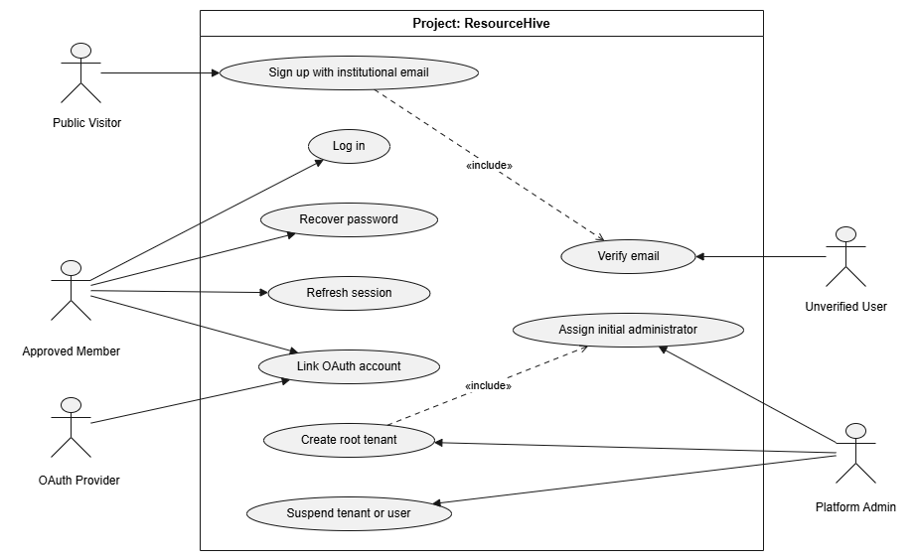
Figure 01. Identity and Tenant Onboarding Use Cases

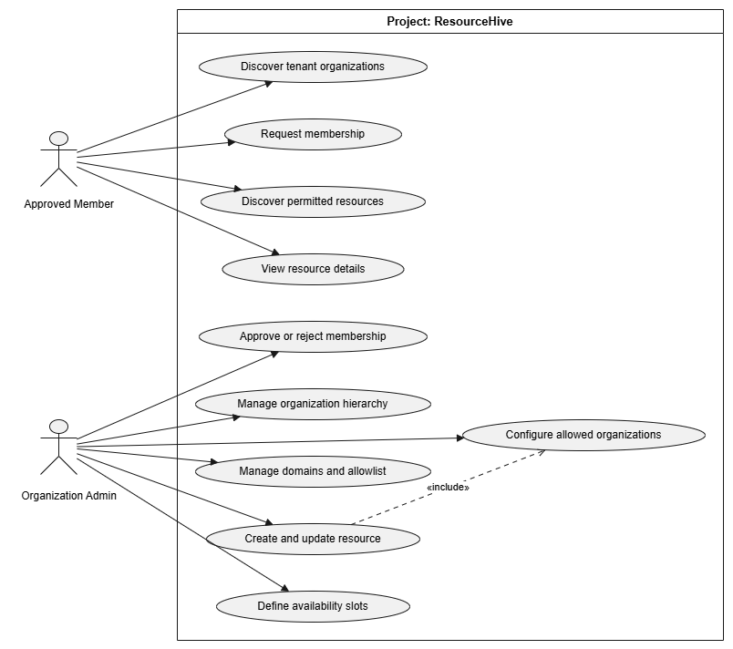

Figure 02. Organization, Membership, and Resource Use Cases

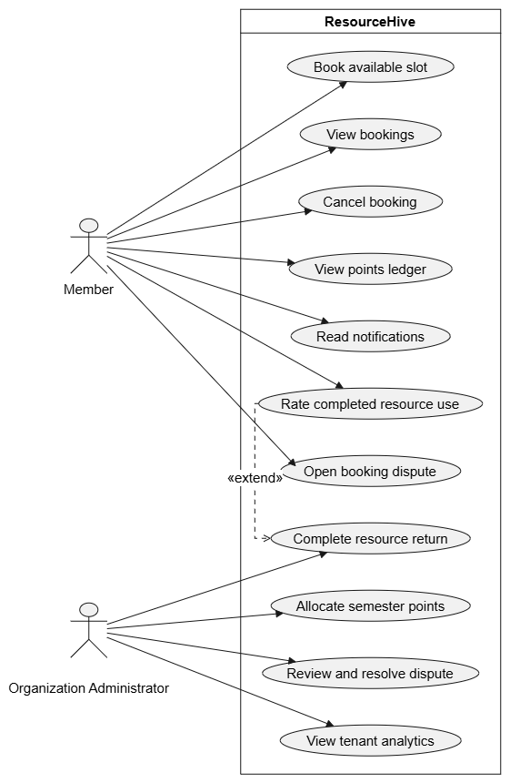

Figure 03. Booking, Points, Notifications, Ratings, and Disputes Use Cases

Use-Case Realizations

4.1.1 Sign up

Use case name | Sign up
Actor | Public Visitor
Description | A public visitor registers for a new account by providing their details and an institutional email address to gain access to the platform.
preconditions | The user must possess a valid institutional email address that is not already registered in the system.
Main flow | - The user navigates to the platform's registration page and enter their name, email and password  - The system validates the email domain against the configured allowlists of active root tenants and create inactive user record in database  - The system generates a secure, time-limited verification token and dispatch email containing the verification link.
Successful end/post condition | An inactive user account is created, and a verification email is successfully sent to the user.
Fail end/post condition | Account creation is rejected if the email domain is invalid, unassociated with any root tenant, or if the email is already registered.
Extensions | If the user clicks the verification link within the allowed timeframe, the system activates the account.

4.1.2 Verify email

Use case name | Verify email
Actor | Public Visitor
Description | A user verifies their institutional email address using a secure token sent to them, confirming their identity.
preconditions | The user has successfully completed the "Sign up" process.
Main flow | - user opens their email client and clicks the verification link  - The system intercepts the request and extracts the token from the URL.  - The system validates that the token exists in the database, belongs to the requesting user, and has not expired.  - The system updates the user's account status to “active”
Successful end/post condition | The user account becomes active, allowing the user to log into the system
Fail end/post condition | If the token is expired, invalid, or already used, the system displays an error message, and the account remains unverified.
Extensions

4.1.3 Log In

Use case name | Log In
Actor | Approved Member, Organization Admin, Platform Admin
Description | An active user authenticates into the system using their credentials to securely access
preconditions | The user must have an active, verified account
Main flow | - The user navigates to the login portal and submits their email address and password.  - The system checks whether the provided credentials match a registered user.  - The system generates JWT token containing the user's ID, roles, and root tenant context.
Successful end/post condition | The user is successfully authenticated, receives an active session token, and is redirected to their respective dashboard.
Fail end/post condition | If the credentials do not match or the account is suspended, authentication is denied, and show error message
Extensions | <<N/A>>

4.1.4 Discover Organizations & Request Membership

Use case name | Discover Organizations & Request Membership
Actor | Approved Member
Description | A member browses available child organizations within their institution and submits a formal request to join.
preconditions | The user is authenticated and is verified as belonging to a specific root tenant.
Main flow | - The user navigates to the organization discovery dashboard.  - The system retrieves and displays a list of active child organizations belonging strictly to the user's root tenant to enforce data isolation.  - The user selects a specific child organization and clicks the "Request to Join" button.  - The system dispatches a notification to the respective Organization Admin indicating a new pending request.
Successful end/post condition | A pending membership request is successfully recorded in the database, and the administrator is notified to take action.
Fail end/post condition | The request fails and is blocked if the user already has a pending request, or attempts to bypass tenant boundaries.
Extensions | <<N/A>>

4.1.5 Find Resources

Use case name | Find Resources
Actor | Approved Member
Description | A member searches for and views the details of available resources that their approved organizations have explicit permission to access.
preconditions | The user is authenticated and holds an 'Approved' membership status in at least one child organization.
Main flow | - The user navigates to the resource directory.  - The system identifies all organizations where the user currently has an 'Approved' status.  - The system queries the database for active resources whose allowlists include any of the user's approved organizations.  - The system displays the filtered, authorized list of resources to the user.  - The user selects a specific resource to view its details, required point cost, and future availability slots.
Successful end/post condition | The user successfully views a list of resources and their details
Fail end/post condition | If the system cannot retrieve the data due to a backend service failure, an appropriate error state is displayed.
Extensions | The user can apply filters (date range, specific organization, or resource type) to narrow down the displayed list of resources.

4.1.6 Book a Resource Slot

Use case name | Book a Resource Slot
Actor | Approved Member
Description | A member reserves a specific time slot for an available resource, resulting in an atomic deduction of points from their account.
preconditions | The member must be authenticated, belong to an organization that is permitted to access the resource, and possess a point balance greater than or equal to the resource's cost. The target time slot must be available.
Main flow | - The member browses the available resources and selects a specific item then selects an available time slot and submits a booking request.  - The system applies a database lock on the selected slot to prevent concurrent double-booking.  - The system records a negative point transaction to deduct the required cost from the member.  - The system updates the slot status to "CONFIRMED" and assigns it to the member.  - The system dispatches a booking confirmation notification to the member.
Successful end/post condition | The slot is successfully reserved, the exact point cost is deducted from the user's ledger, and a notification is sent.
Fail end/post condition | The booking is rejected if the slot is simultaneously claimed by another concurrent request, or if the user has insufficient points.
Extensions | <<N/A>>

4.1.7 Cancel Own Booking

Use case name | Cancel Own Booking
Actor | Approved Member
Description | A member cancels an upcoming resource booking they previously made, freeing the time slot and triggering an automatic refund of the deducted points.
preconditions | The user is authenticated and has an active, confirmed booking for a future time slot that has not yet passed the organization's cancellation cutoff time.
Main flow | - The user navigates to their personal bookings management page.  - The user selects a confirmed future booking and executes the "Cancel" action.  - The system verifies that the current timestamp is before the designated cancellation cutoff time for that specific resource.  - The system updates the booking status to 'Cancelled', making the time slot available for other members and records a positive transaction in the append-only ledger, refunding the exact point cost to the user's account.  - The system notifies the user of the successful cancellation and updated point balance.
Successful end/post condition | The booking is officially canceled, the time slot becomes publicly available again, and the points are accurately refunded.
Fail end/post condition | Cancellation is rejected if the cutoff time has already passed.
Extensions | <<N/A>>

4.1.8 View Point History

Use case name | View Point History
Actor | Approved Member
Description | A member views their personal append-only ledger detailing all point transactions, including joining bonuses, booking deductions, and cancellation refunds.
preconditions | The user is authenticated.
Main flow | - The user navigates to the point management dashboard.  - The system shows all append-only ledger transactions with details of each transaction (date, amount,description).  - The system calculates the current total point balance and shows balance.
Successful end/post condition | The user successfully views their accurate, up-to-date point transaction history and total balance.
Fail end/post condition | If the ledger service is unreachable, an error message is displayed and the history fails to load.
Extensions | The user can filter the ledger history by specific date ranges or transaction types.

4.1.9 View and Manage Notifications

Use case name | View and Manage Notifications
Actor | Approved Member
Description | A member views system alerts, such as booking confirmations, membership approvals, or upcoming reservation reminders, and marks them as read.
preconditions | The user is authenticated.
Main flow | - The user clicks on the notifications icon in the application header.  - The system retrieves the list of recent notifications for the user, sorting unread items at the top.  - The user clicks an action to mark the notification as "Read".
Successful end/post condition | The notifications are successfully retrieved, viewed, and their state is updated to 'Read'.
Fail end/post condition | If the notification service is down, the alert dropdown will not load.
Extensions | The user can select a "Mark all as read" option to update the state of all unread notifications simultaneously.

4.1.10 Create and Manage Root Tenants

Use case name | Create and Manage Root Tenants
Actor | Platform Admin
Description | The platform administrator provides a new root tenant (university) to allow their respective members to utilize the platform in an isolated environment.
preconditions | The actor must be authenticated and hold Platform Admin privileges.
Main flow | - The Platform Admin navigates to the tenant management dashboard and selects "Create New Tenant".  - The Admin inputs the tenant details, including the organization name and the permitted email registration domains.  - The system validates that the provided domains are unique and not currently in use by another tenant.  - The system creates the root organization record.  - The Admin assigns initial administrative accounts to manage the new root tenant.
Successful end/post condition | A newly isolated root tenant is active in the system, and public visitors with matching domains can begin registering.
Fail end/post condition | Creation is aborted, and an error is returned if the requested email domains conflict with an existing root tenant.
Extensions | <<N/A>>

4.1.11 Create Child Organization

Use case name | Create Child Organization
Actor | Organization Admin
Description | An administrator creates a new nested organization ( a specific club or department) within their overarching root tenant structure
preconditions | The admin must be authenticated and possess Organization Admin privileges within the root tenant.
Main flow | - The Admin navigates to the organization management dashboard and selects "Create Child Organization".  - The Admin inputs the required details (name, description,category,..)  - The system validates the inputs and creates the child organization record in the database.  - The system automatically assigns the creator as an Organization Admin for the newly created child organization.
Successful end/post condition | The child organization is successfully created, stored in the database, and becomes visible for members to discover and request to join.
Fail end/post condition | Creation fails if a duplicate name is used or if the database connection is interrupted.
Extensions | <<N/A>>

4.1.12 Approve/Reject Membership

Use case name | Approve/Reject Membership
Actor | Organization Admin
Description | An organization administrator reviews a pending request from a member attempting to join their specific child organization.
preconditions | The admin must be authenticated, hold Organization Admin privileges for the target organization, and there must be at least one pending membership request.
Main flow | - The Admin navigates to the organization's pending memberships dashboard.  - The Admin reviews a specific user's request details and selects the “Approve” action.  - The system updates the user’s membership status and automatically credits the user with the organization's configured joining bonus points via a new ledger transaction.  - The system dispatches an approval notification to the user.
Successful end/post condition | The user is added as an active member, receives the joining bonus points, and gains access to resources restricted to that organization.
Fail end/post condition | The approval fails if the requesting user's account has been deactivated or if the admin's privileges have been revoked during the process.
Extensions | If the Admin selects 'Reject', the system updates the membership status to 'Rejected' and notifies the user.

4.1.13 Create and Manage Resources

Use case name | Create and Manage Resources
Actor | Organization Admin
Description | An administrator creates a new shared resource (equipment, a study room,...) and explicitly defines which internal child organizations are permitted to book it.
preconditions | The admin must be authenticated and hold privileges to create resources within their organization.
Main flow | - The Admin selects the 'Create Resource' option within their dashboard.  - The Admin inputs the resource details, including name, description, and the point cost per booking.  - The Admin selects one or more internal child organizations to add to the resource's allowlist.  - The system validates that all selected organizations belong to the exact same root tenant to enforce tenant isolation.  - The system saves the resource and generates its initial availability calendar.
Successful end/post condition | The resource becomes active and is immediately discoverable by approved members of the explicitly allowed organizations.
Fail end/post condition | Resource creation is blocked if the admin attempts to grant access to an organization outside of their root tenant boundary.
Extensions | The Admin may later edit the resource to modify its point cost, update the list of allowed organizations, or adjust availability time slots.

4.1.14 Manage Email Allowlist

Use case name | Manage Email Allowlist
Actor | Organization Admin
Description | An administrator adds specific email addresses to a pre-approved list, allowing those users to automatically bypass the manual membership approval process.
preconditions | The admin must be authenticated and have administrative rights for the target child organization.
Main flow | - The Admin navigates to the organization's settings and selects the "Email Allowlist" section.  - The Admin enters a list of specific user email addresses.  - The system validates provided emails and updates the organization's allowlist database record.
Successful end/post condition | The allowlist is updated. Any future membership request from a user with a matching email address will be automatically approved by the system.
Fail end/post condition | The update is rejected if improperly formatted email addresses are submitted.
Extensions | The Admin can also remove previously added email addresses from the allowlist to revoke auto-join privileges.

4.1.15 Configure Organization Rules

Use case name | Configure Organization Rules
Actor | Organization Admin
Description | An administrator customizes specific platform behaviors for their organization, such as setting the joining bonus points awarded to new members.
preconditions | The admin must be authenticated and hold Organization Admin privileges.
Main flow | - The Admin navigates to the "Organization Rules & Settings" dashboard.  - The Admin modifies the "Joining Bonus" value to a specified integer.  - The Admin adjusts any other available parameters such as resource cancellation cutoff limits… and submits the changes.  - The system validates the inputs and updates the organization's configuration record in the database.
Successful end/post condition | The new rules are saved and immediately applied to all subsequent platform actions
Fail end/post condition | The system rejects the update if invalid data types are submitted.
Extensions | <<N/A>>

4.1.16 View Bookings

Use case name | View Bookings
Actor | Approved Member
Description | A member views their current and previous resource bookings and the status of each booking.
preconditions | The member must be authenticated and have an active account.
Main flow | - The member navigates to the “My Bookings” page.  - The system validates the member’s JWT locally.  - The system retrieves only bookings belonging to the authenticated member.  - The system displays each booking with its resource, slot, status, point cost, and relevant timestamps.  - The member selects a booking to view its complete details.
Successful end/post condition | The member successfully views their tenant-scoped booking history and booking details.
Fail end/post condition | If the booking information cannot be retrieved, the system displays an appropriate error message.
Extensions | The user can filter bookings by status, resource, or date range.

4.1.17 Complete Resource Return

Use case name | Complete Resource Return
Actor | Organization Administrator
Description | An authorized organization administrator confirms that a resource has been returned or that its reserved use has been completed.
preconditions | The administrator must be authenticated and authorized to manage the organization that owns the resource. The booking must have a CONFIRMED status.
Main flow | - The administrator navigates to the booking or return-management page.  - The system displays confirmed bookings for resources managed by the administrator.  - The administrator selects a booking and confirms the resource return.  - The system validates the administrator’s authority and the current booking status.  - The system changes the booking status to COMPLETED and records the completion timestamp.  - The system sends a completion notification to the member.
Successful end/post condition | The booking is marked as completed, the completion timestamp is recorded, and the member is notified.
Fail end/post condition | Completion is rejected if the administrator is unauthorized or the booking has already been cancelled or completed.
Extensions | After completion, the member may rate the resource or open an eligible dispute.

4.1.18 Allocate Semester Points

Use case name | Allocate Semester Points
Actor | Organization Administrator
Description | An organization administrator allocates points to eligible members for a particular academic semester.
preconditions | The administrator must be authenticated and have administrative authority over the target organization. The semester must be registered under the same root tenant.
Main flow | - The administrator navigates to the semester-points management page.  - The administrator selects the relevant semester and organization.  - The administrator selects the eligible members and enters the number of points to allocate.  - The system verifies that the semester, organization, and selected members belong to the same root tenant.  - The system records a positive SEMESTER_ALLOCATION transaction for each eligible member.  - The system recalculates and displays the members’ updated point balances.
Successful end/post condition | The semester points are allocated to the selected members and recorded in the append-only points ledger.
Fail end/post condition | The allocation is rejected if the administrator is unauthorized, a member is ineligible, the allocation crosses a tenant boundary, or the same allocation has already been made.
Extensions | The administrator may allocate points to multiple eligible members in a single operation.

4.1.19 Rate Completed Resource Use

Use case name | Rate Completed Resource Use
Actor | Approved Member
Description | A member submits a rating and an optional comment for a resource after completing their booking.
preconditions | The user must be authenticated and must own a COMPLETED booking for the resource. The booking must not already have a rating.
Main flow | - The member opens a completed booking.  - The system displays the option to rate the resource.  - The member selects a rating from one to five and optionally enters a comment.  - The system validates booking ownership, completion status, tenant scope, resource matching, and rating range.  - The system stores the resource rating.  - The resource’s average rating is recalculated from its eligible ratings.
Successful end/post condition | The rating is stored and becomes part of the resource’s rating information
Fail end/post condition | The rating is rejected if the score is invalid, the booking is incomplete, the booking belongs to another user, or a rating already exists for it.
Extensions | The user may include an optional written comment with the rating.

4.1.20 Open Booking Dispute

Use case name | Open Booking Dispute
Actor | Approved Member
Description | A member opens a dispute concerning one of their eligible resource bookings.
preconditions | The user must be authenticated, own the relevant booking, and have no existing dispute for that booking.
Main flow | - The member opens the relevant booking.  - The member selects “Open Dispute.”  - The member provides a reason, description, and optional supporting evidence.  - The system validates booking ownership, eligibility, tenant scope, and uniqueness.  - The system creates a BookingDispute with the status OPEN.  - The system creates an append-only OPENED dispute event identifying the member as the actor.  - The system notifies the authorized organization administrators.
Successful end/post condition | A tenant-scoped dispute is created in the OPEN state, and the administrator is notified.
Fail end/post condition | The dispute is rejected if the booking is unauthorized, ineligible, cross-tenant, or already has a dispute.
Extensions | The member may submit additional evidence while the dispute remains open or under review.

4.1.21 Review and Resolve Dispute

Use case name | Review and Resolve Dispute
Actor | Organization Administrator
Description | An authorized organization administrator reviews a booking dispute and resolves or rejects it.
preconditions | The administrator must be authenticated and have authority over the organization responsible for the disputed resource. The dispute must be OPEN or UNDER_REVIEW.
Main flow | - The administrator opens the dispute-management dashboard.  - The system displays disputes within the administrator’s tenant and organization authority.  - The administrator selects an open dispute.  - The system changes its status to UNDER_REVIEW and records an append-only event.  - The administrator reviews the booking, reason, description, and submitted evidence.  - The administrator enters resolution notes and selects RESOLVED or REJECTED.  - The system records the reviewer, final status, resolution notes, and resolution timestamp.  - The system adds the corresponding append-only dispute event and notifies the member.
Successful end/post condition | The dispute is marked as RESOLVED or REJECTED, its audit history is preserved, and the member is notified.
Fail end/post condition | The operation is rejected if the administrator lacks authority, the dispute belongs to another tenant, or required resolution information is missing.
Extensions | The administrator may request or add evidence and notes before reaching a decision. Any point correction must be recorded as a new append-only point transaction.

4.1.22 View Tenant Analytics

Use case name | View Tenant Analytics
Actor | Organization Administrator
Description | An authorized organization administrator views analytics for organizations and resources within their permitted tenant hierarchy.
preconditions | The administrator must be authenticated and possess an approved ADMIN membership for the target organization or an authorized ancestor.
Main flow | - The administrator opens the analytics dashboard.  - The system validates the administrator’s tenant and organization authority.  - The administrator selects an organization, date range, and optional filters.  - The system derives analytics from tenant-scoped resources, bookings, cancellations, point transactions, ratings, disputes, and memberships.  - The system displays summaries and utilization measurements within the administrator’s authority.
Successful end/post condition | The administrator views accurate analytics limited to their authorized tenant and organization hierarchy.
Fail end/post condition | Access is rejected if the administrator requests information from another tenant or an organization outside their administrative authority.
Extensions | The administrator may filter results by date, organization, resource, booking status, or activity type. A root-organization administrator may view tenant-wide analytics.

Logical View

Overview
The ResourceHive design model is decomposed into logically independent subsystems (microservices) to ensure high cohesion, loose coupling, and clear boundaries of ownership. The system logic is primarily divided across four backend domains. Identity, Resource, Booking, and Notification.
These subsystems are supported by shared internal packages to maintain architectural consistency without duplicating critical business logic. Tenant isolation is logically enforced across all packages by scoping queries and actions to a specific root organization id rather than relying on separate databases.

Architecturally Significant Design Packages
Below are the significant packages and their primary classes that govern the platform's core behavior.
- Identity Package
This package is exclusively responsible for user authentication, registration, and credential management.
- User: Represents individuals interacting with the platform.
  - Attributes: id, email, password_hash, status (ACTIVE/SUSPENDED), platform_role.
  - Responsibilities: Acts as the global identity across all tenant organizations.
- VerificationToken / RefreshToken:
  - Responsibilities: Manages time-limited, cryptographically hashed tokens for email verification and session renewal.

- Resource & Organization Package
This package manages the multi-tenant hierarchy and the shared facilities/items.
- Organization: Represents either a root tenant (e.g., a university) or a child unit (e.g., a club or faculty).
  - Attributes: id, parent_id, root_organization_id, status, joining_bonus.
  - Responsibilities: Enforces tenant boundaries. It cannot be its own parent, nor can the hierarchy contain cycles.
- Membership: Connects a User to an Organization.
  - Attributes: role (ADMIN/MEMBER), status (PENDING/APPROVED/REJECTED).
- Resource: Represents a bookable entity.
  - Attributes: id, point_cost, cancellation_period, root_organization_id.
  - Responsibilities: Defines what can be booked and explicitly which organizations (and their approved members) are allowed to access it.

- Booking & Ledger Package
This package handles availability, reservations, append-only point transactions, and post-booking actions like ratings and disputes.
- Booking: Represents a user's reservation of a resource slot.
  - Attributes: id, status (CONFIRMED/CANCELLED/COMPLETED), completedAt, cancelledAt.
  - Responsibilities: Ensures only one active booking exists per slot and correctly tracks lifecycle timestamps.
- PointTransaction: Represents an append-only entry in the points ledger.
  - Attributes: type (JOIN_BONUS, BOOKING, BOOKING_REFUND, SEMESTER_ALLOCATION), amount.
  - Responsibilities: Maintains the integrity of a user's point balance without modifying or deleting past transactions.
- BookingDispute: Manages conflict resolution for completed or cancelled bookings.
  - Attributes: reason, status (OPEN/UNDER_REVIEW/RESOLVED), resolutionNotes.

- Notification Package
This package manages the delivery and persistence of system alerts.
- Notification:
  - Attributes: id, type, title, message, readAt, createdAt.
  - Responsibilities: Persists recipient-scoped alerts and tracks read statuses to ensure users can view history even if real-time WebSockets fail.
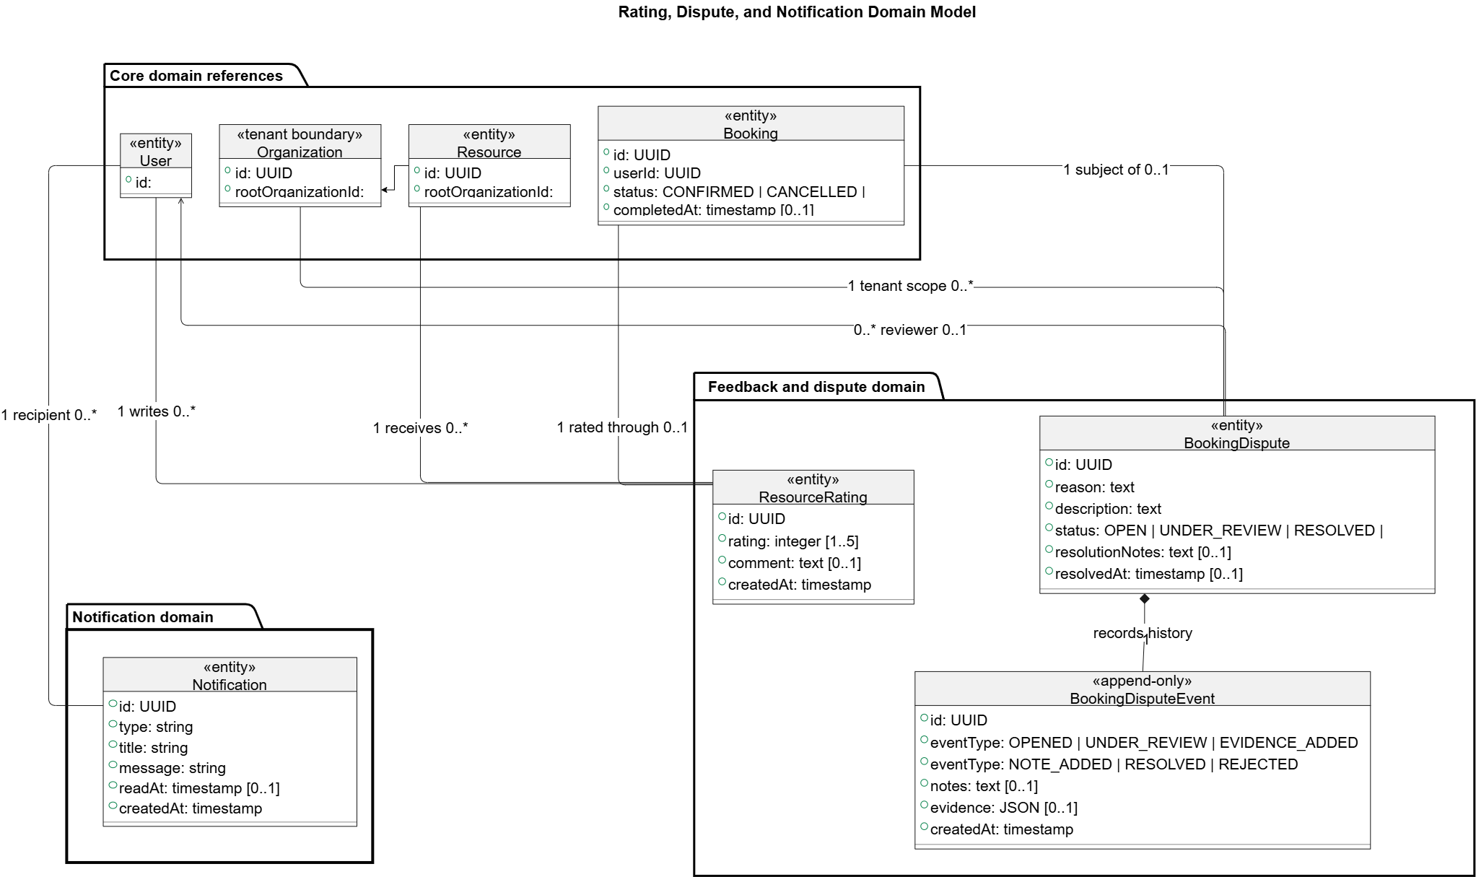
Figure 7. Resource, Booking, Points, and Semester Domain Classes

The Class Diagram illustrates the structural relationships and strict tenant boundaries within the ResourceHive architecture:
- Tenant Boundary (Organization & Resource): The diagram highlights that both Organization and Resource entities contain a rootOrganizationId. This structural relationship is critical for tenant isolation, ensuring that a resource and its owner always belong to the same root tenant.
- Booking Lifecycle (Booking): The Booking class acts as a central junction, linking a User (via userId) to a specific resource slot. It manages the state machine of the reservation with its status attribute (CONFIRMED, CANCELLED) and tracks fulfillment via the completedAt timestamp.
- Feedback & Dispute Domain:
- The diagram shows that a Booking has a 1 to 0..1 relationship with ResourceRating, meaning a completed booking can optionally be rated exactly once.
- Similarly, a Booking has a 1 to 0..1 relationship with BookingDispute. The BookingDispute class is composed of BookingDisputeEvent entities. The <<append-only>> stereotype on the event class dictates that all state changes, evidence additions, and resolutions are recorded as a permanent, immutable history.
- Recipient-Scoped Alerts (Notification): The Notification class has a many-to-one dependency on the User class (as a recipient), utilizing readAt and createdAt timestamps to manage the user's inbox state.

Process View
- Identity Onboarding and Authentication Sequence Diagram
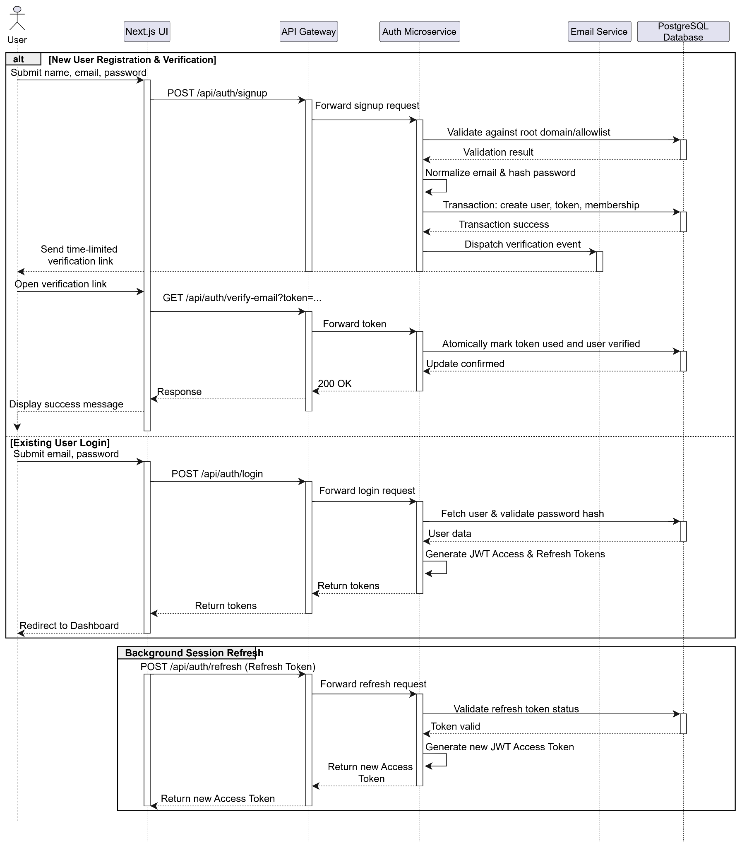

- Authenticated Request and Role Validation Sequence Diagram
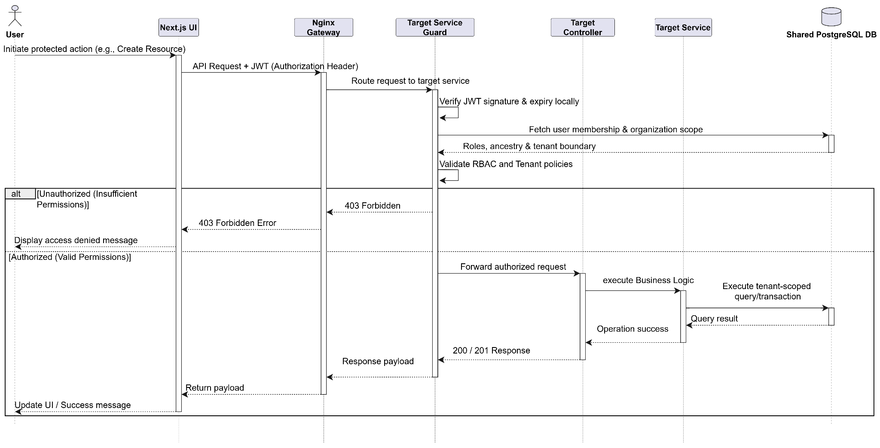
- Tenant and Organization Hierarchy Setup Sequence Diagram
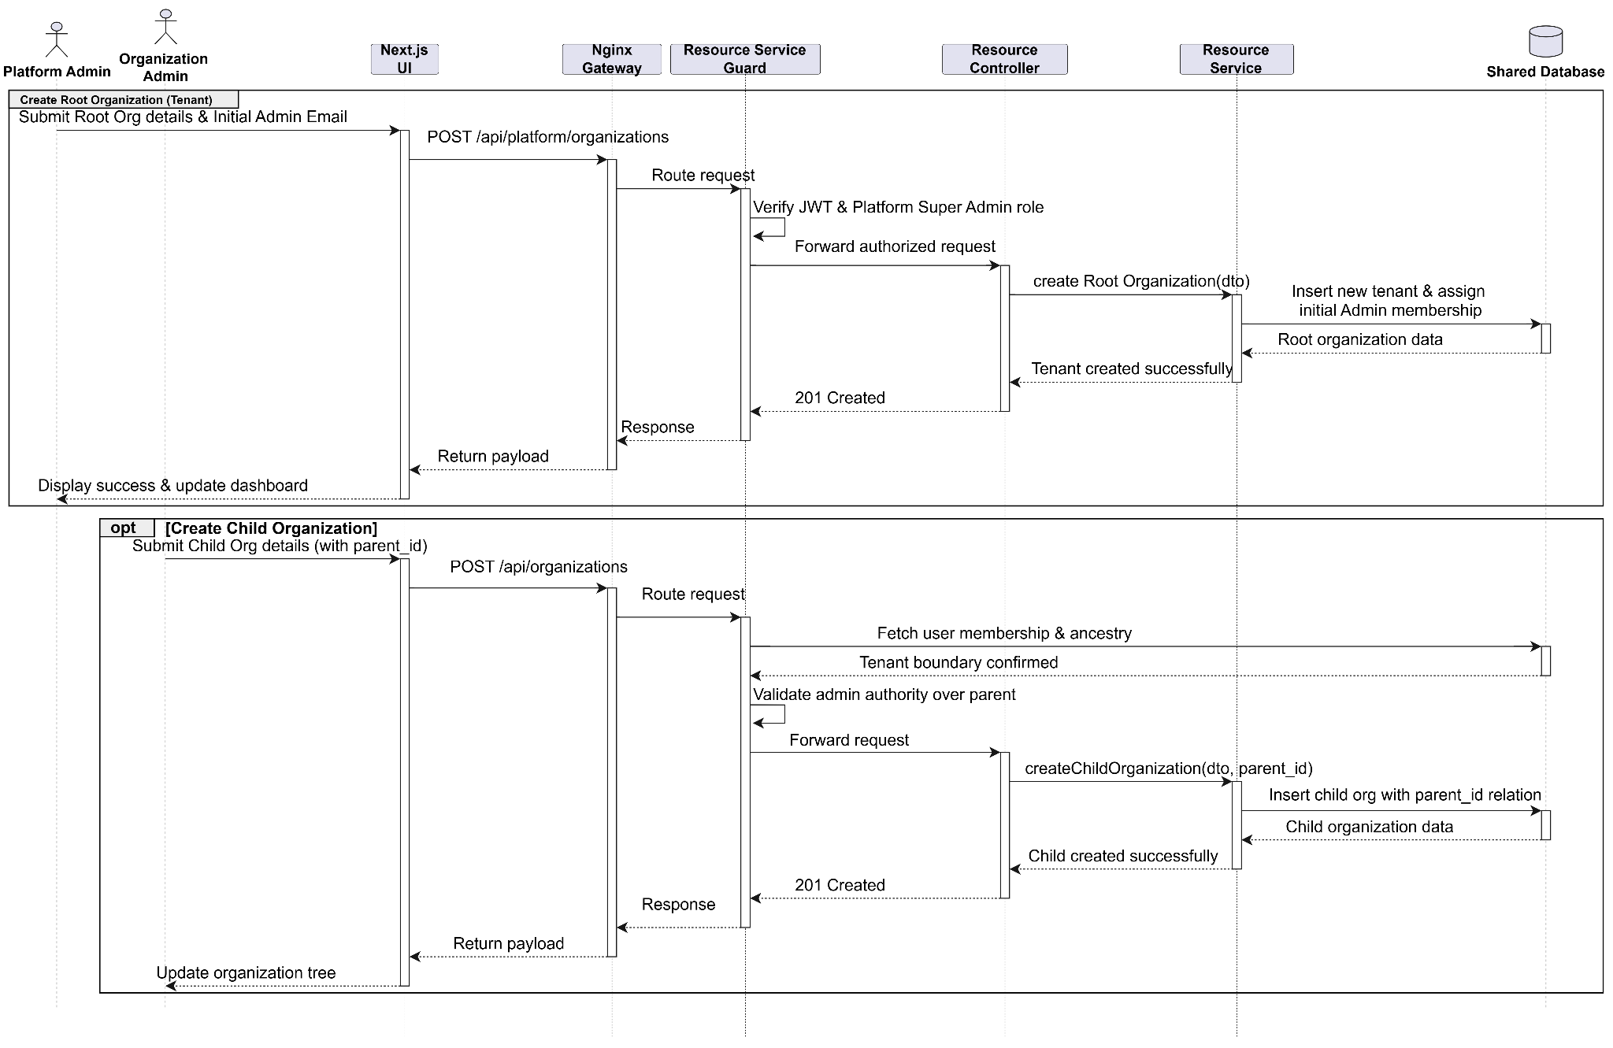
- Resource Creation and Allowlist Configuration Sequence Diagram

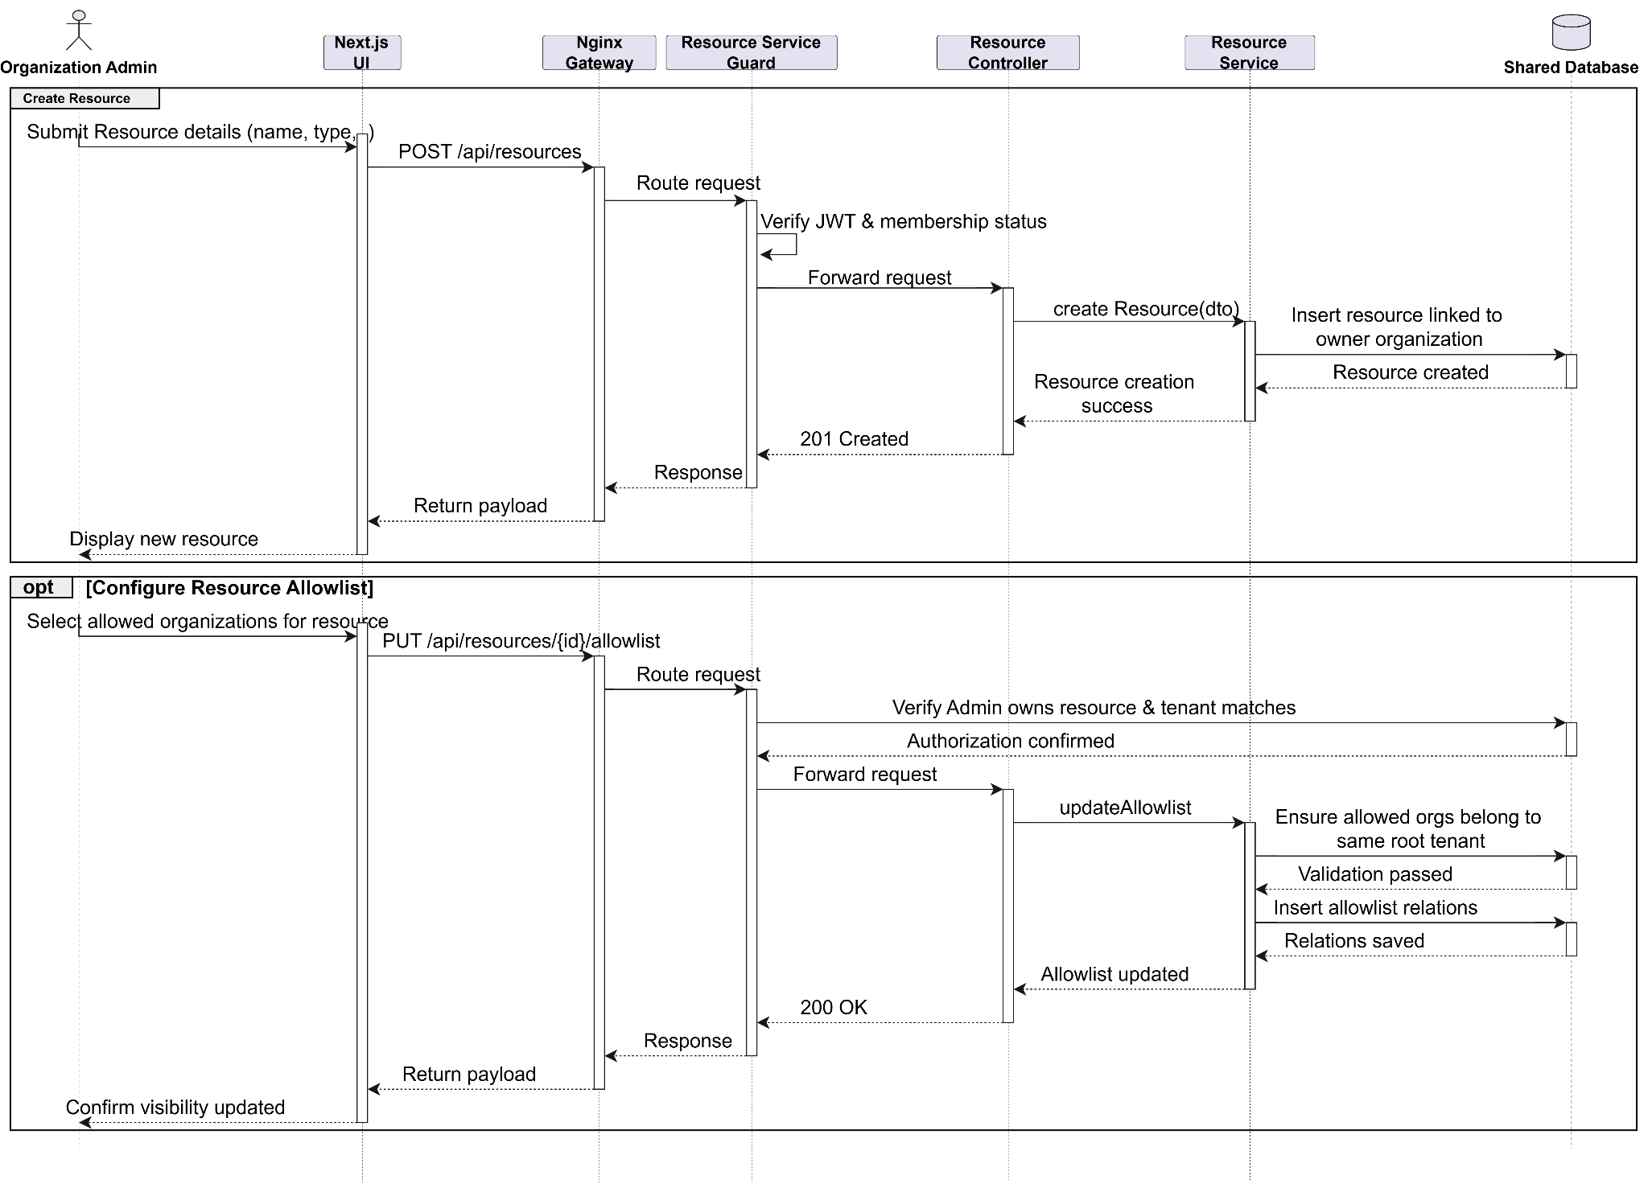

\

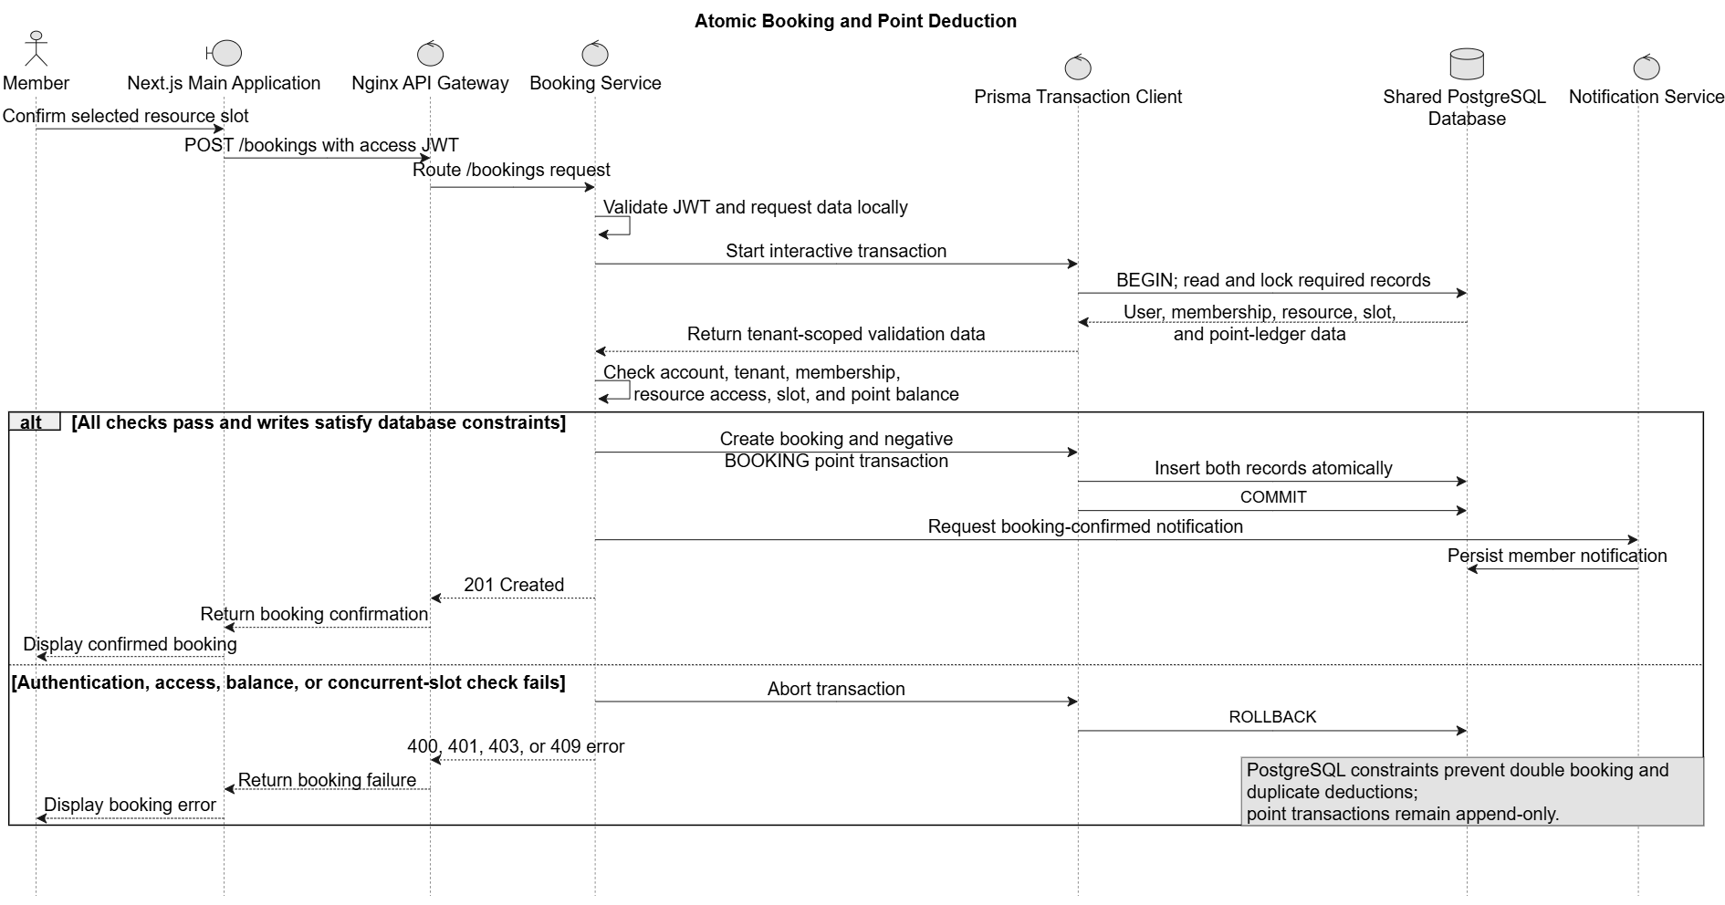
Figure 12. Atomic Booking and Point Deduction

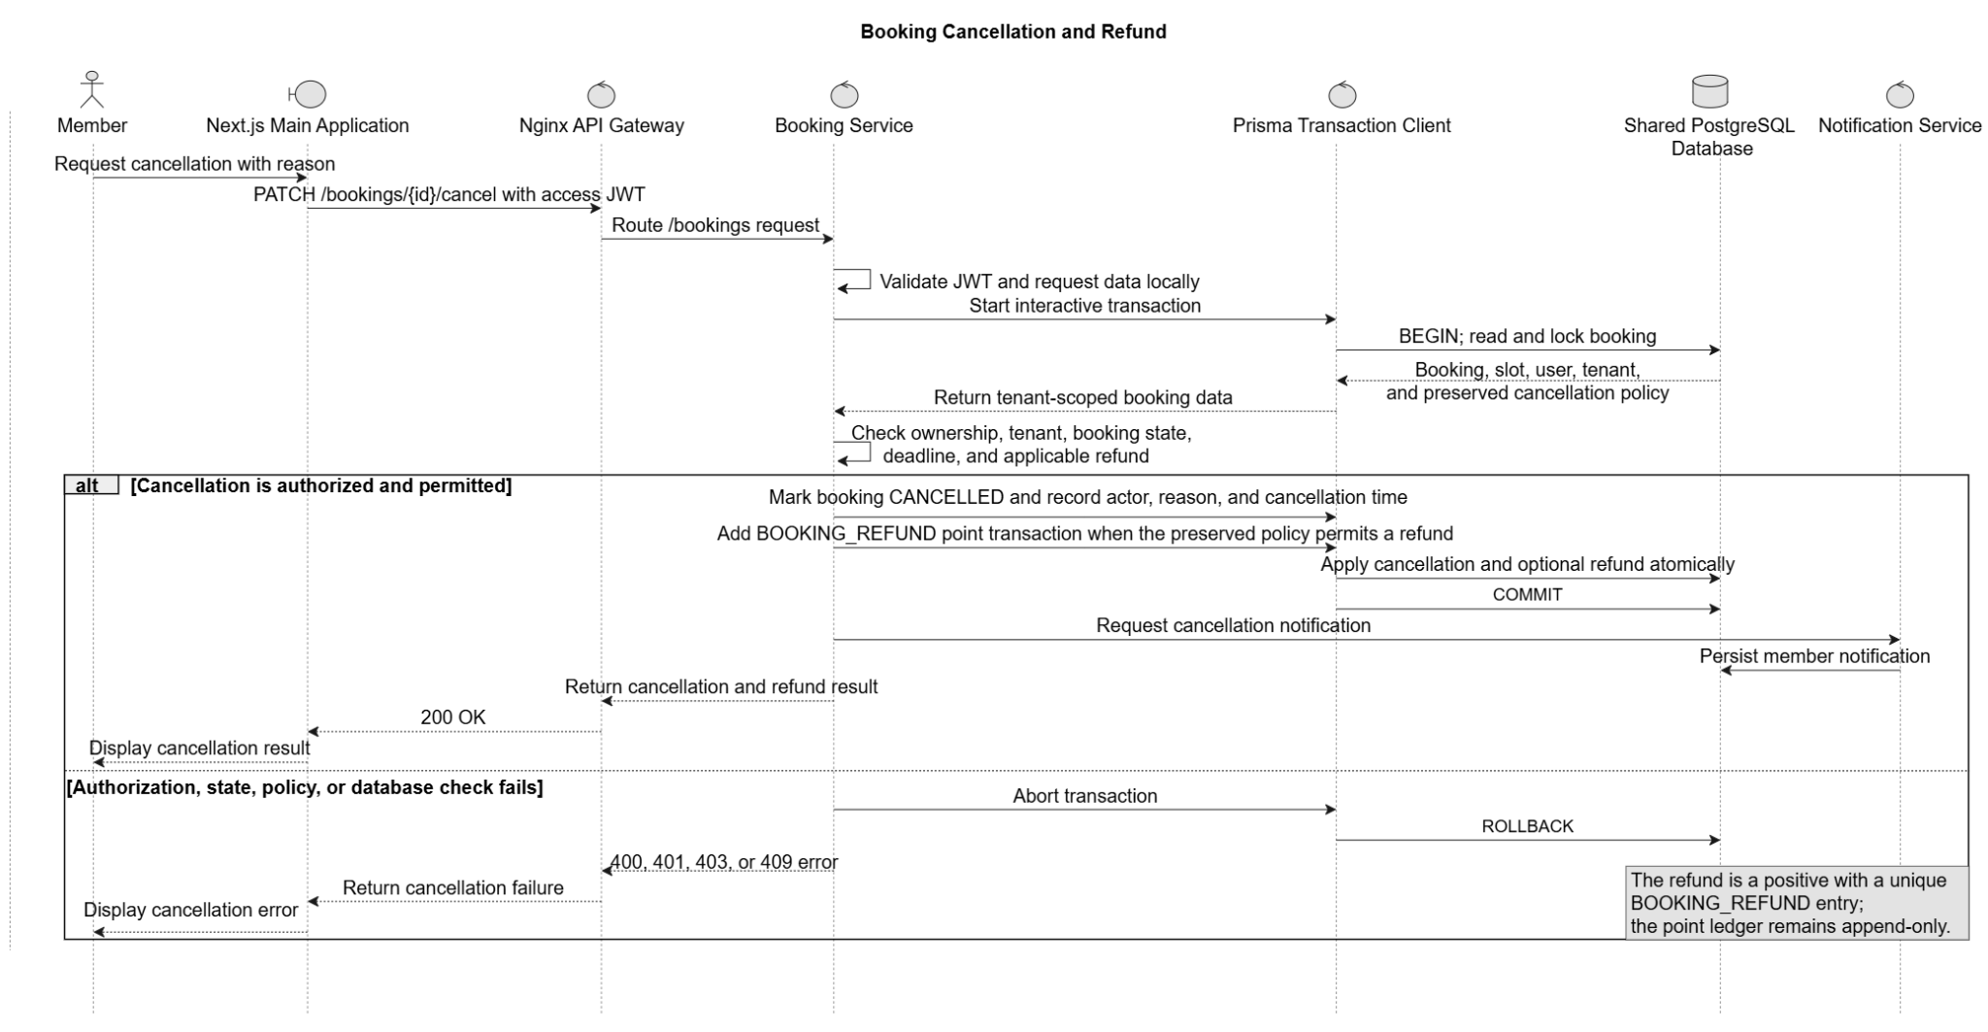
Figure 13. Booking Cancellation and Refund

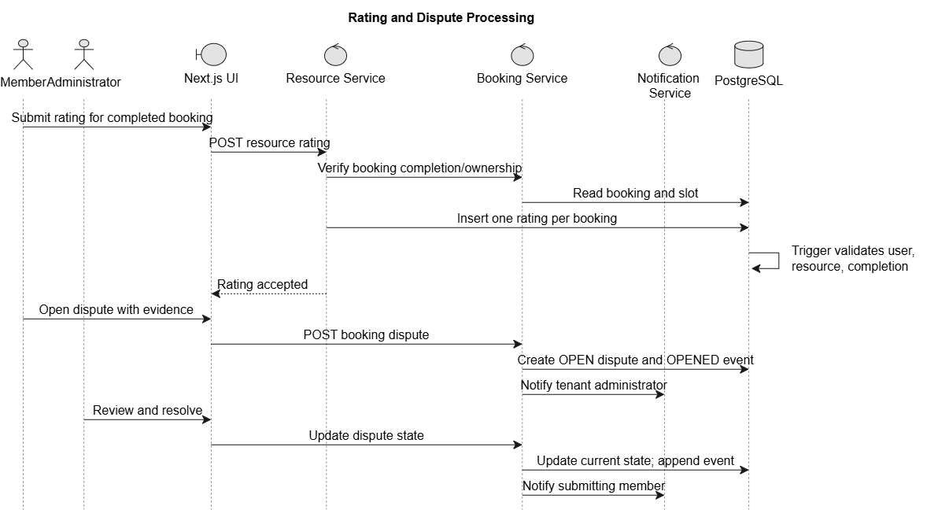

Figure 14. Rating and Dispute Processing
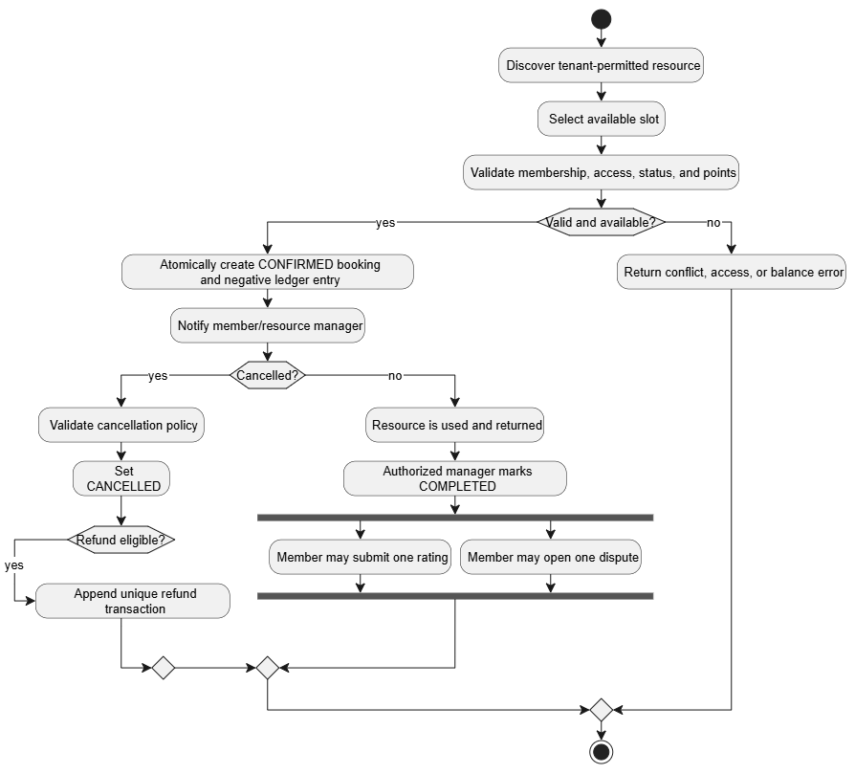
Figure 16. Booking Lifecycle Activity
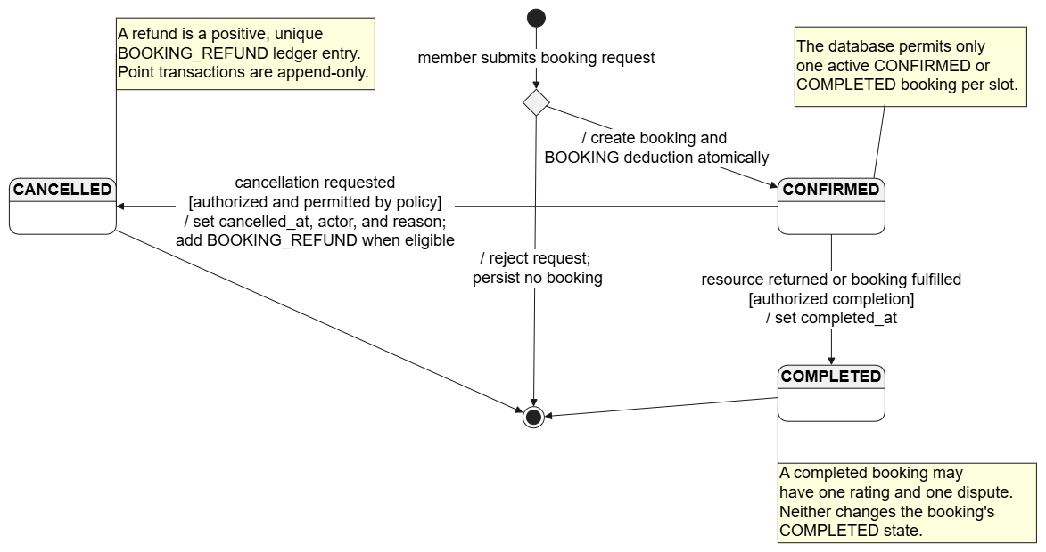
Figure 17. Booking State Model

User Registration and Email Verification Activity Diagram
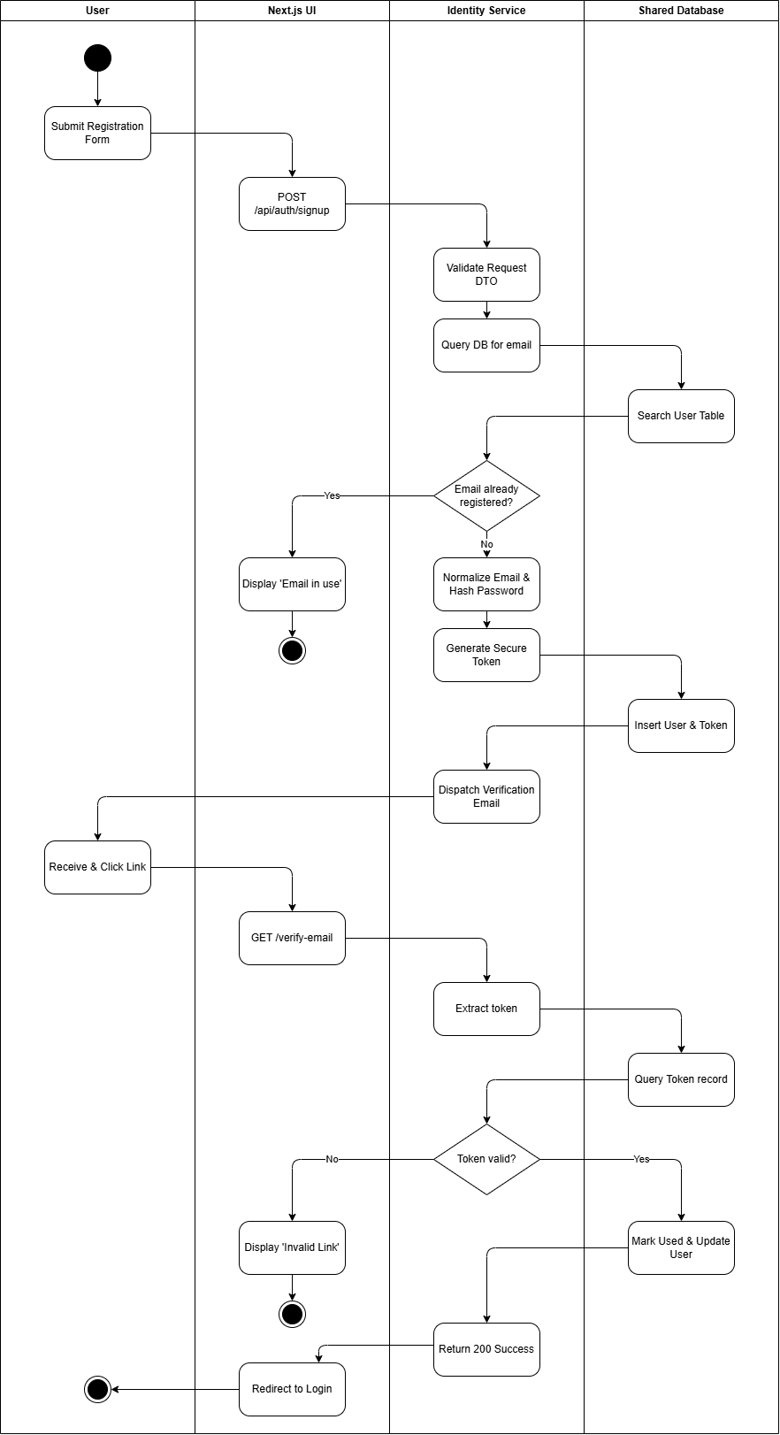
Membership Request and Admin Approval Activity Diagram
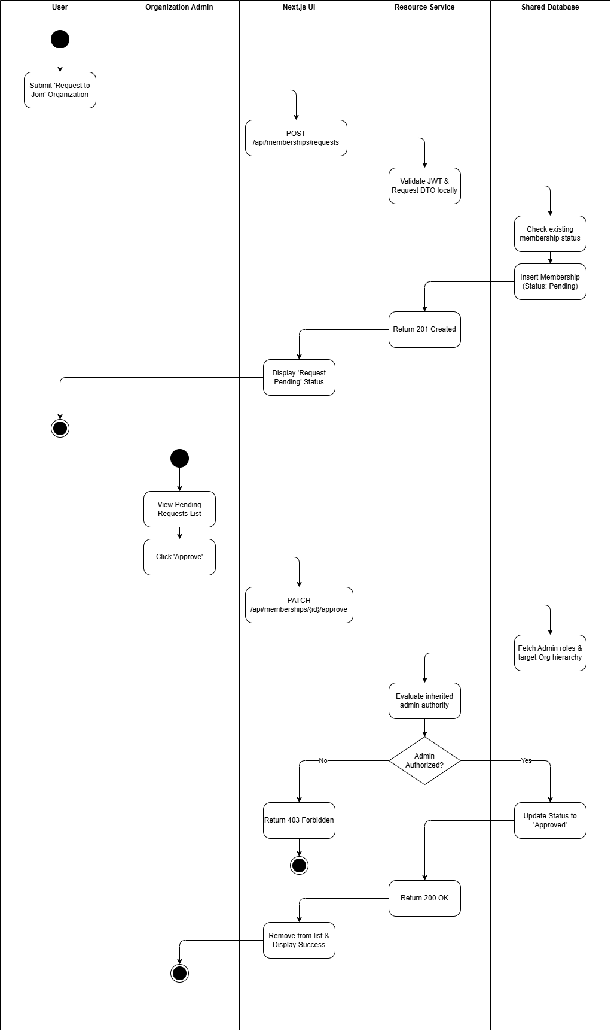
Resource Creation and Visibility Configuration Activity Diagram
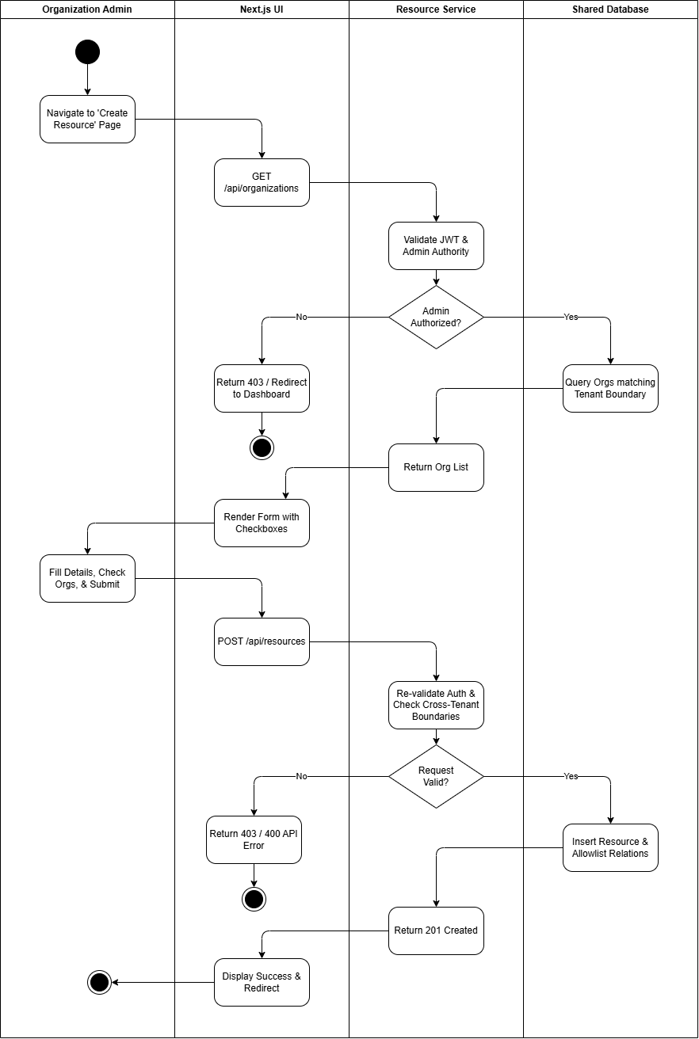

Deployment View
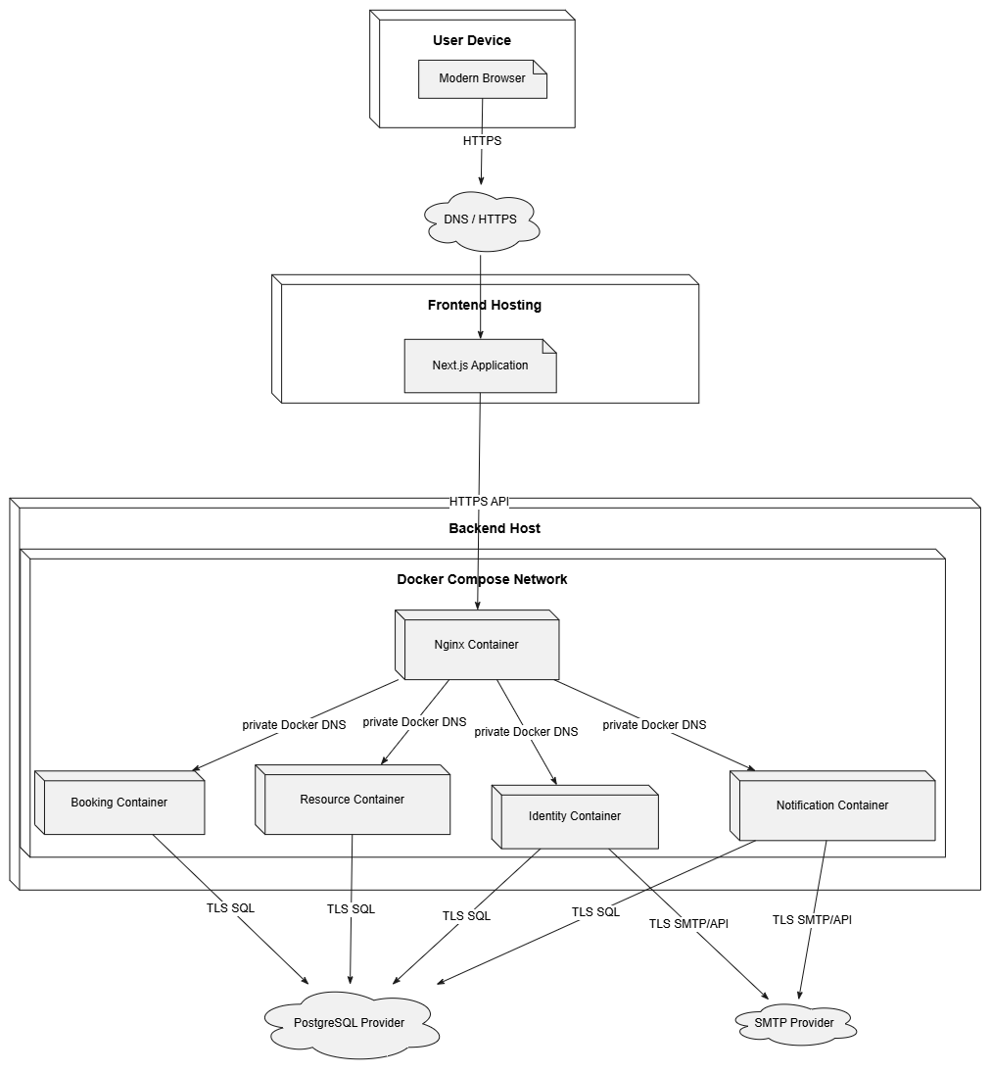

Implementation View
[This section describes the overall structure of the implementation model, the decomposition of the software into layers and subsystems in the implementation model, and any architecturally significant components.]

Overview
[This subsection names and defines the various layers and their contents, the rules that govern the inclusion to a given layer, and the boundaries between layers. Include a component diagram that shows the relations between layers. ]

Layers
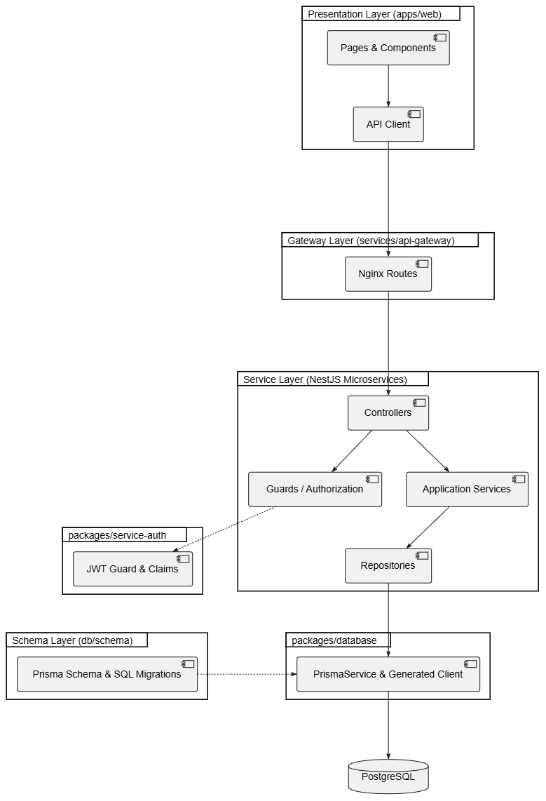

Data View (optional)
[A description of the persistent data storage perspective of the system. This section is optional if there is little or no persistent data, or the translation between the Design Model and the Data Model is trivial.]

Size and Performance
[A description of the major dimensioning characteristics of the software that impact the architecture, as well as the target performance constraints.]

Quality
[A description of how the software architecture contributes to all capabilities (other than functionality) of the system: extensibility, reliability, portability, and so on. If these characteristics have special significance, such as safety, security or privacy implications, they must be clearly delineated.]

12. References
Refer any data/ information in a standard format (eg. IEEE referencing style)
For different algorithms/ techniques/ theories you can refer text books.
For tools you can refer web pages.
For similar work you can refer research paper articles that describe the work.
You may include white paper articles for the description of technologies; web URL for the tool references. When you refer such a web page, you have to indicate the (Accessed on <<date>>)

